Downloading the Data

UKDS, Nadia Kennar

28/10/2021

This document provides some extra information on how to download the datsets required for the project.

All data can be found via git *link*

### Crime Data

Follow the link <https://data.police.uk/>

* Select ‘Downloads’
* In date range select ‘January 2019 to December 2019’
* Select ‘Surrey Police’ and
* select ‘Include Crime Data’.
* Download and unzip the data into your working directory

We will be using just the 08/2020 reported crimes rep.

crime01_19 <- read_csv("Data/2020-08/2020-08-surrey-street.csv") %>%   
 janitor::clean_names()

##   
## -- Column specification --------------------------------------------------------  
## cols(  
## `Crime ID` = col_character(),  
## Month = col_character(),  
## `Reported by` = col_character(),  
## `Falls within` = col_character(),  
## Longitude = col_double(),  
## Latitude = col_double(),  
## Location = col_character(),  
## `LSOA code` = col_character(),  
## `LSOA name` = col_character(),  
## `Crime type` = col_character(),  
## `Last outcome category` = col_character(),  
## Context = col_logical()  
## )

## Shapefle

To optain boundary data we will use the <https://borders.ukdataservice.ac.uk/bds.html>

Steps to download:

* Select; England, Statistical Building Block, 2011 and later
* Click ‘Find’
* Select ‘English Lower Layer Super Output Areas’
* Click ‘List Areas’
* Select ‘Surrey Health’
* Click ‘Extract Boundary Data’

Read in the Shapefile for ‘Surrey Heath’

shp_file <- st_read("Data/Shapefile/england_lsoa_2011.shp")

## Reading layer `england_lsoa_2011' from data source `C:\Users\naken\OneDrive\Documents\Research Associate\Work\Crime Mapping\CrimeMapping\Data\Shapefile\england_lsoa_2011.shp' using driver `ESRI Shapefile'  
## Simple feature collection with 55 features and 3 fields  
## Geometry type: MULTIPOLYGON  
## Dimension: XY  
## Bounding box: xmin: 485406.9 ymin: 154122.5 xmax: 501181.2 ymax: 166842.9  
## Projected CRS: OSGB 1936 / British National Grid

## Census Data

To obatin population statistics use <http://infuse2011gf.ukdataservice.ac.uk/>

* Select ‘Geography’
* Expand the ‘Local Authorities’ tab in England
* Tick and expand ‘Surrey Heath’
* Select ‘Lower Super Output area and Data Zones (55 areas)’
* Select ‘Add’ and ‘Next’

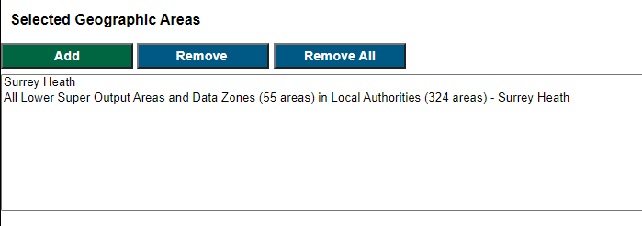

* Click ‘Population (usual residence)’
* Click Next
* Under unit select ‘Persons’ and under ‘Population (usual residents)’ select ‘All usual residets in households’
* Click ‘Add’

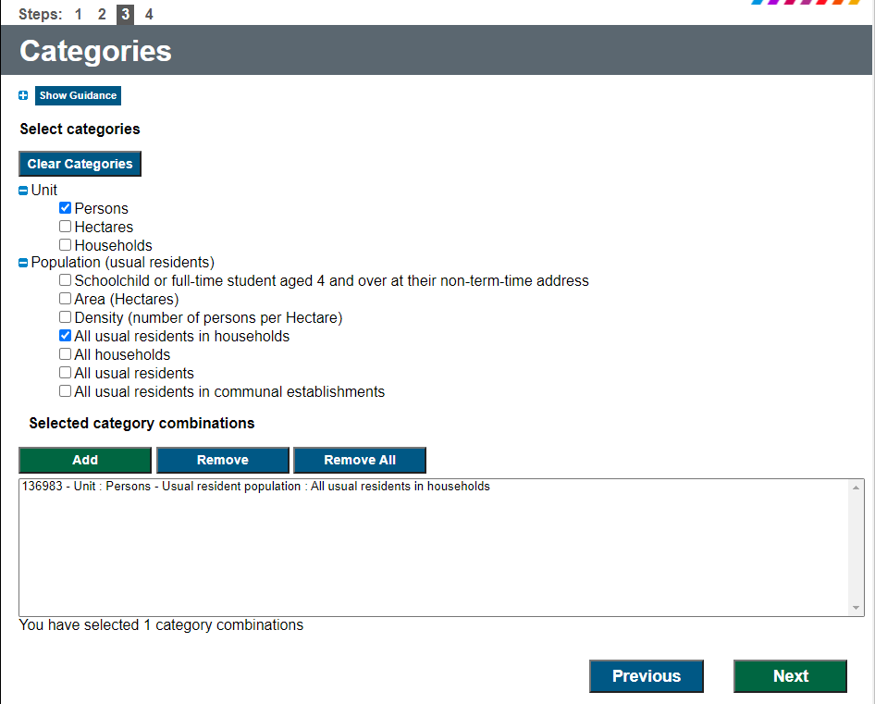

* Click ’Next and download the data

To read in the data

pop <- read_csv("Data/Census Population/Data_UNIT_URESPOP.csv") %>%   
 slice(3:47) %>% #removes first and second row  
 select(2,3,6,7) %>% #selects the columns of interest  
 janitor::clean_names() %>% #cleans the names   
 rename(pop_count = f136983) %>% #rename the variable  
 mutate(pop_count = as.numeric(pop_count)) #turns variable to numeric

## Warning: Missing column names filled in: 'X8' [8]

##   
## -- Column specification --------------------------------------------------------  
## cols(  
## CDU_ID = col_double(),  
## GEO_CODE = col_character(),  
## GEO_LABEL = col_character(),  
## GEO_TYPE = col_character(),  
## GEO_TYP2 = col_character(),  
## F2383 = col_character(),  
## F136983 = col_character(),  
## X8 = col_logical()  
## )